**ASSIGNMENT 5.1**

PROBLEM STATEMENT:

**1)** **Top 5 employees (employee id and employee name) with highest rating. (In case two employees have same rating, employee with name coming first in dictionary should get preference).**

Query:

emp = LOAD '/home/acadgild/pig/employee_details' USING PigStorage(',') AS (emp_id:int, emp_name:chararray, emp_salary:int,emp_ratings:int);

ordered_emp = ORDER emp by emp_ratings DESC;

five_emp = LIMIT ordered_emp 5;

dump five_emp;

Output:

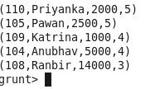

**2)** **Top 3 employees (employee id and employee name) with highest salary, whose employee id is an odd number. (In case two employees have same salary, employee with name coming first in dictionary should get preference)**

Query:

ordered_emp_salary = ORDER emp by emp_salary DESC

filtered_emp_id = FILTER ordered_emp_salary by emp_id%2!=0;

three_emp = LIMIT filtered_emp_id 3;

dump three_emp;

Output:

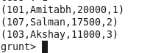

**3)** **Employee (employee id and employee name) with maximum expense (In case two employees have same expense, employee with name coming first in dictionary should get preference)**

Query:

emp_expenses = LOAD 'employee_expenses' AS (emp_id:int, expenses:int);

left_outer_joined_data = join emp by emp_id left outer, emp_expenses by emp_id;

ordered_expenses = ORDER left_outer_joined_data by emp_expenses::expenses DESC;

dump ordered_expenses;

Output:

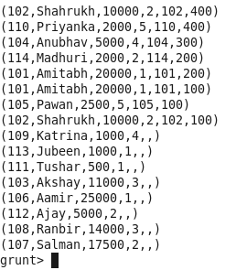

**4)** **List of employees (employee id and employee name) having entries in employee_expenses file.**

Query:

filtered_emp = FILTER left_outer_joined_data by emp_expenses::emp_id is not null;

dump filtered_emp;

Output:

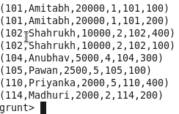

**5)** **List of employees (employee id and employee name) having no entry in employee_expenses file.**

Query:

filtered_emp = FILTER left_outer_joined_data by emp_expenses::emp_id is null;

Output:

